SDP Liferay Implementation Architecture Document

Table of Contents

Project Description: 2

Architectural Descirption 2

Liferay Application Server details : 3

Production Topology : 3

Dependent Systems: 3

Liferay Features Implemented in portal: 4

Database : 4

UserManagement : 4

Role Management : 4

Permission System : 4

Portlets 4

Themes 4

DMS 4

CMS 4

Data & Business Service : 5

Notification Engine: 5

Service Business and Network Governance : 5

Scheduling Engine : 5

Search Engine : 5

Caching Engine : 5

Exepctations: 5

# Project Description:

ELM has different products and services hosted on web to enable access of government services to its customers

ELM in order to improve its operations and better serve their customers, has embarked on this initiative to develop a Service Oriented Architecture based Service Delivery Platform, re-implement its current applications on the new platform, and implement a robust billing system to compliment ELM’s operations. ELM’s envisioned Service Delivery Platform is defined as a software platform deployed at ELM and across different partner boundaries, enabling the development, testing and delivery of services to different customers including individuals, businesses and government. As such the SDP provides multiple environments to ELM implementation team and other teams providing business services leveraging SOA concepts.

# Architectural Description

SDP has SDP Core as kernel platform with different Products over it where in Liferay each product is configured as one instance with its own theme and portlets .

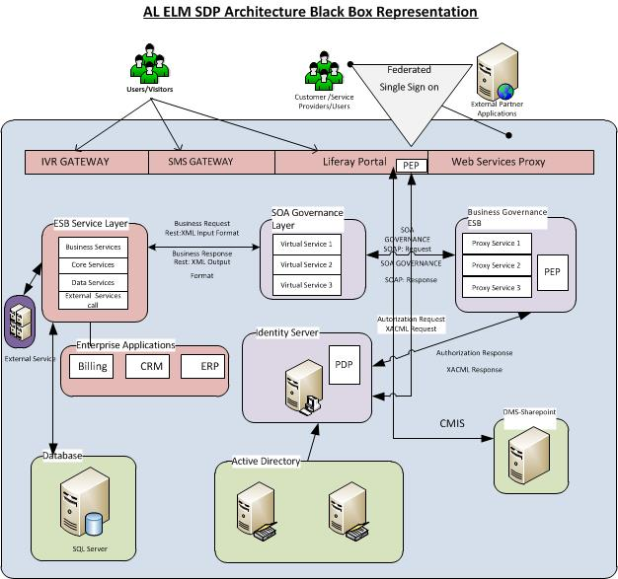

# Liferay Application Server details :

Application Server: Jboss

Operating Server: RHEL

Clustered: Yes

For Development, Testing and UAT servers Liferay 6.1 C.E Edition

For Pilot and Production: Liferay 6.1 EE Edition

## Production Topology :

Portal server – 2 node – Liferay EE

## Dependent Systems:

ESB as a backEnd system for Business and Database Service

IDAM – for Authenticaion and Authorization Purpose

SOA governance System – For Business and Network governance

Caching Server –Using distributed Caching mechanism

Sharepoint server as DMS

# Liferay Features Implemented in portal:

Currently Liferay is used at Presentation Tier with minimal liferay features implemented

## Database :

SDP has one common Database containing Business and application data used by all system

Where one more Database with liferay related schema is used just for liferay core functionalities purpose(with only liferay tables .)

## UserManagement :

Storing Users in Liferay DB also in the LDAP which is the user store for the Identity Server used for authentication and authorization

## Role Management :

Liferay feature for Role Management is not being used .Instead Identity Server of WSO2 with LDAP as user store is being used for authentication and authorization (Authentication/Authorization)

## Permission System :

Liferay feature of Page permission system is not being used, instead every page access is being authorized and the page load if the authorization succeeds.

## Portlets

Spring MVC portlets

## Themes

Different Themes for each Product

## DMS

Liferay is using SharePoint as DMS using cmis for document related CRUD operations

## CMS

The CMS is implementation using Liferay feature in Bootstrap,

Regarding Web Content (No Structure and Templates) is being implemented and used.

## Data & Business Service:

Liferay Service builder feature is not being used .Instead Software AG ESB product is being used for Business and Data service system, through REST service

## Notification Engine:

Notification is handled by Software AG ESB Product since the related business logic and data service logic is handle by backend system.

## Service Business and Network Governance:

For governance and monitoring of all the Rest service calls for Business and Data service, SOA governance system is being used

## Scheduling Engine:

Businesses related job scheduling is being handled by Backend Services.

## Search Engine:

Solr search is being implementation by using the Web Plugin provided by liferay, customized the liferay search behavior.

## Caching Engine:

Currently distributed caching mechanism using EhCache is being implemented with Terracotta as Caching Server

# Expectations:

Performance Analysis and tuning assessment

Best practice verifications